Case 8-CAN-NW Coast-Inuit-Anorak-Sea Mammal Intestines-Sinew thread

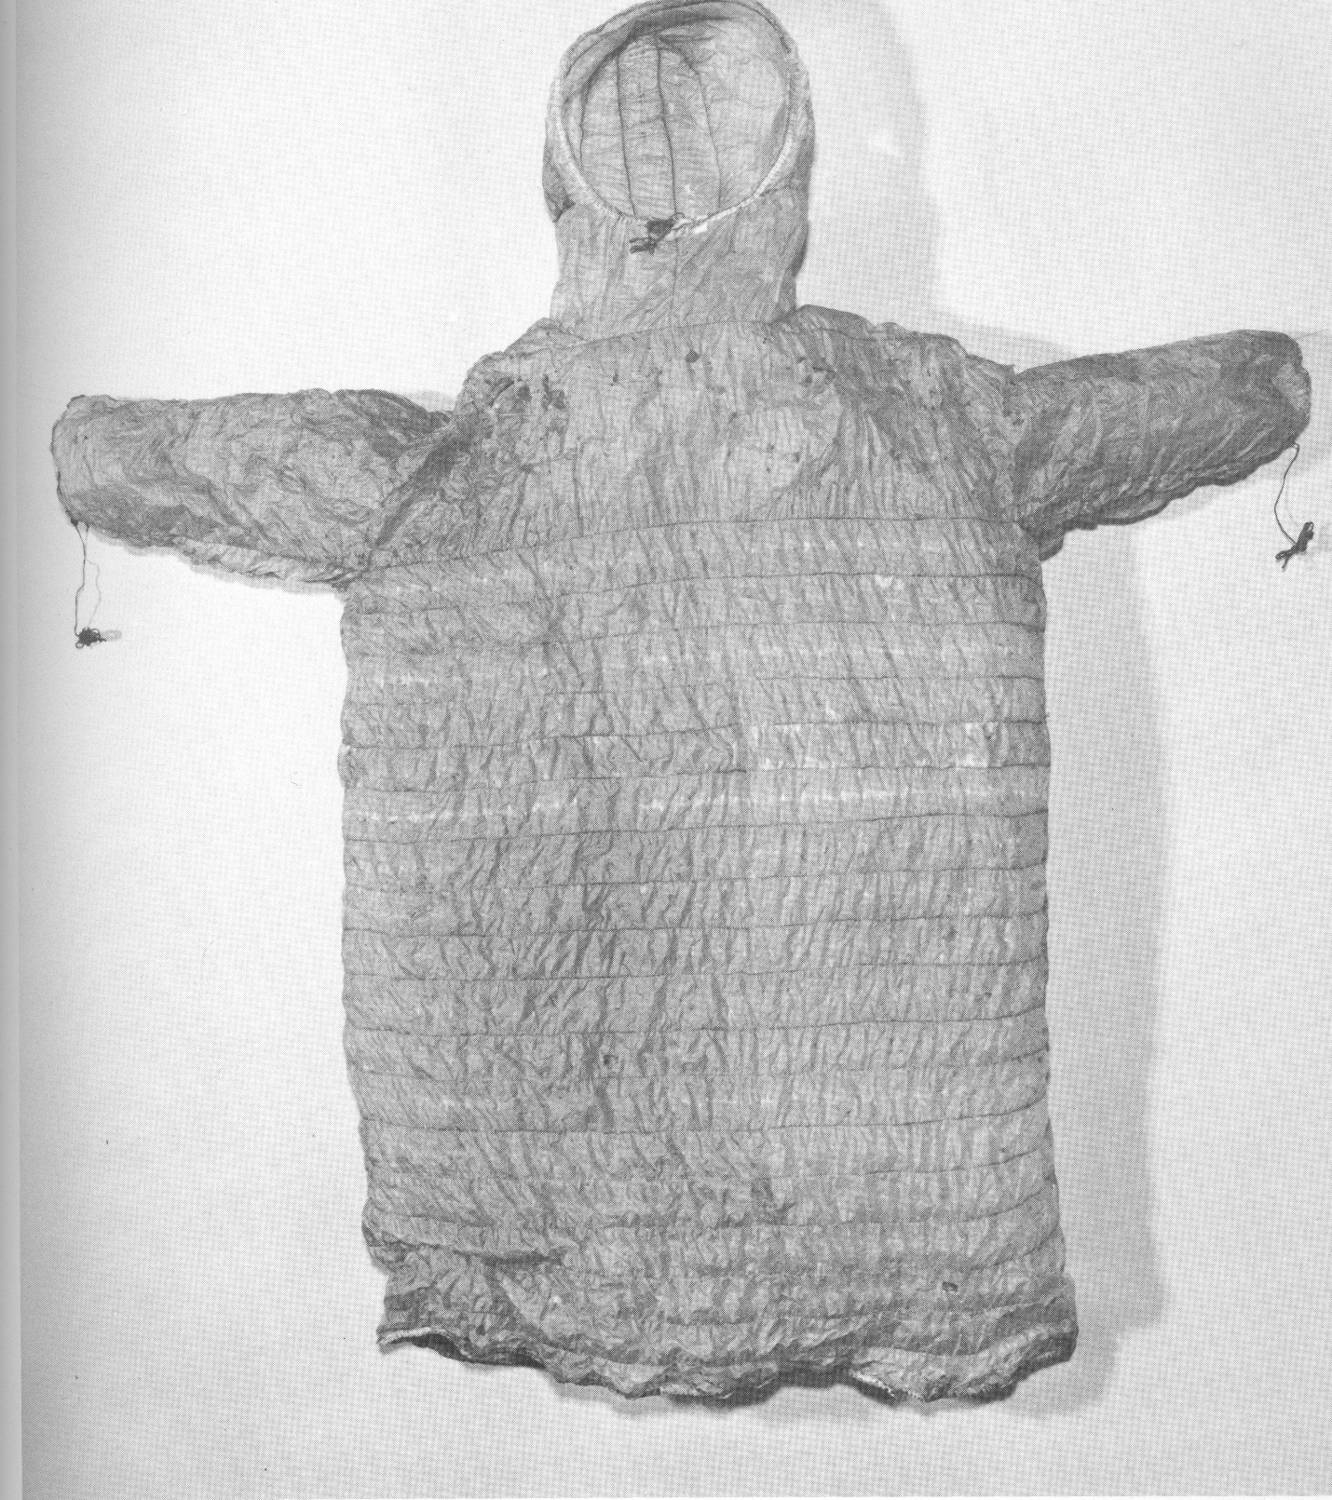

A gut frock made of sea mammal intestines horizontally sewn with sinew, with a hood constructed as an integral part of the garment.